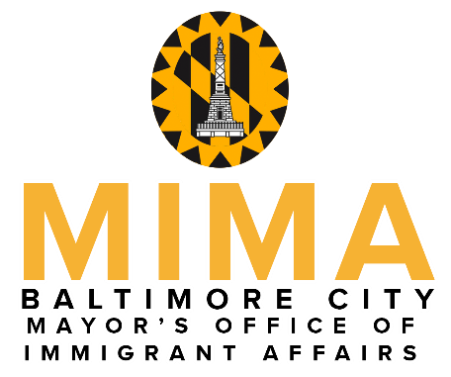

Mayor Brandon M. Scott

presents

The 2023 Mayor’s Hispanic Heritage Awards
To recognize exemplary individuals who have made outstanding contributions toward improving quality of life within the Hispanic community in Baltimore City

Nomination Guidelines
- Fill out the nomination form below by listing the sponsor, the nominee, nomination category, and the reasons the candidate should be recognized for their work.
- Complete the application online at Mayor's Hispanic Heritage Awards Nomination Form | Mayor's Office of Immigrant Affairs (baltimorecity.gov) . If you’re having difficulty with the website please download your application and send it to mima@baltimorecity.gov.
- Nomination forms MUST BE RECEIVED by Monday, August 7, 2023.

- A selection committee will review all of the nominations.
- Sponsors & winners will be notified by Saturday, September 30, 2023.
- When final details are available, this page will be updated, and the event will also be announced via MIMA’s Facebook page.

For more information, contact mima@baltimorecity.gov
Nomination Form

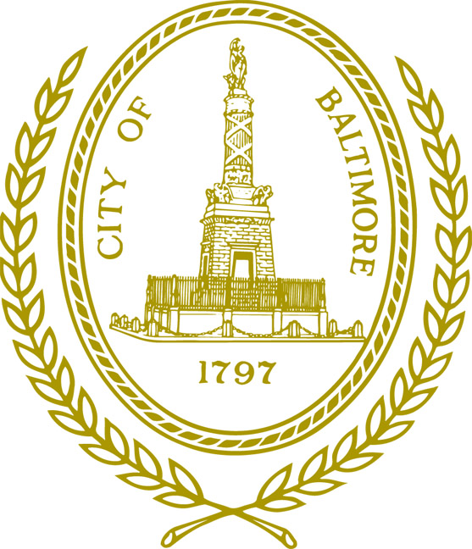
NOMINATOR

Name

Cell Phone Number Alt. Phone Number

Mailing Address for Contact Person Zip Code

Baltimore, MD

E-mail Address

Category (choose only one)

۝ Emerging leader (must be 21 years of age or under)
۝ Educator (works in education or training in the Latino community, any field)
۝ Service Provider (works for a non-profit organization or business that serves the Latino comm.)
۝ Volunteer (works with the Latino community above and beyond their job responsibilities; must be 22 years of age or over)
۝ Delfina Haydee Pereda Echeverria Award (for a community member whose work demonstrates the bridge building and compassion of the late Delfina Haydee Pereda Echeverria)

NOMINEE

Name Telephone Number

Mailing Address Zip Code

Baltimore, MD

E-mail Address

FOR EMERGING LEADER, EDUCATOR, SERVICE PROVIDER, or VOLUNTEER: Please provide a description of the nominee’s work in the Hispanic/Latino community. What is the impact of their work? Nominees whose work has provided assistance to those impacted by the ongoing COVID-19 pandemic will be given priority. Include brief biographical information. (300-400 words)

FOR THE DELFINA HAYDEE PEREDA ECHEVERRIA AWARD: Please provide a description of the nominee’s work as it relates to building bridges between the Hispanic/Latinx community and other entities or communities in Baltimore City. Their work should be in the spirit of the late Delfina Haydee Pereda Echeverria for whom the award is named. (300-400 words)

Date:

